THE UNITED REPUBLIC OF TANZANIA

 | MINISTRY OF HEALTH  MUHIMBILI NATIONAL HOSPITAL  MLOGANZILA | 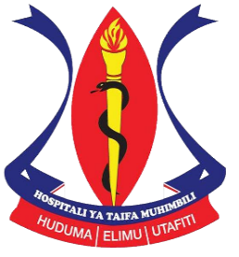

Aggressive Angiomyxoma of Vulva a Rare Condition: Case and Literature Review
Dr Joseph Gasper Kimaro¹, Dr Peter J.T. Wangwe², Dr Innocent Mosha³
¹Temeke Regional Referral Hospital, Box 45232, Dar es Salaam, Tanzania.
^{2,3}Muhimbili University of Health and Allied Sciences, P.O. Box 65000, Dar es salaam, Tanzania

DOI: https://doi.org/10.51244/IJRSI.2025.12040085
Abstract

Aggressive angiomyxoma (AA) is a rare, benign mesenchymal tumor predominantly affecting women of reproductive age. Despite its benign nature, AA exhibits locally infiltrative growth and a high propensity for recurrence. We report a case of a 40-year-old female presenting with recurrent vulvar swelling, managed through wide excision and adjuvant radiotherapy. The histological evaluation confirmed AA. This manuscript discusses the clinical presentation, diagnostic imaging, histopathology, and management approaches, focusing on surgical excision and adjunct therapies. Literature findings highlight the need for a multidisciplinary approach and follow-up to ensure favorable outcomes.

Keywords: Aggressive Angiomyxoma of the vulva, vulva tumor, labial tumor, perineal mass

